DEADLOCKS:
- A process requests resources; if the resources are not available at that time, the process enters a waiting state. Sometimes, a waiting process is never again able to change state, because the resources it has requested are held by other waiting processes. This situation is called a deadlock.
- The resources of a computer system may be partitioned into several types such as CPU cycles, files, and I/O devices (such as printers and DVD drives)
- A process must request a resource before using it and must release the resource after using it.
- A process may utilize a resource in only the following sequence.
  - Request. The process requests the resource. If the request cannot be granted immediately then the requesting process must wait until it can get the resource.
  - Use. The process can operate on the resource
  - Release. The process releases the resource.

NECESSARY CONDITIONS FOR DEADLOCKS:
- A deadlock situation can arise if the following four conditions hold simultaneously in a system:
    - Mutual exclusion. At least one resource must be held in a non-sharable mode; that is, only one process at a time can use the resource.
    - Hold and wait. A process must be holding at least one resource and waiting to acquire additional resources that are currently being held by other processes.
    - No preemption. Resources cannot be preempted; that is, a resource can be released only voluntarily by the process holding it, after that process has completed its task.
    - Circular wait. A set {P0, P1, ..., Pn} of waiting processes must exist such that P0 is waiting for a resource held by P1, P1 is waiting for a resource held by P2, ..., Pn−1 is waiting for a resource held by Pn, and Pnis waiting for a resource held by P0.

RESOURCE ALLOCATION GRAPH:
- Deadlocks can be described more clearly in terms of a directed graph called a system resource-allocation graph.
- This graph consists of a set of vertices V and a set of edges E.
- The set of vertices V is partitioned into two different types of nodes P = {P1, P2, ...,Pn}, the set consisting of all the active processes in the system, and R = {R1, R2, ..., Rm}, the set consisting of all resource types in the system.
- A directed edge Pi → Rjis called a request edge; a directed edge Rj→ Pi is called an assignment edge
- Represent each process Pi as a circle and each resource type Rjas a rectangle.
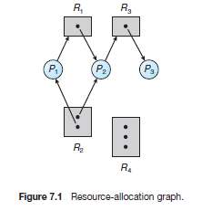
- The sets P, R, and E:
P = {P1, P2, P3}
R = {R1, R2, R3, R4}
E = {P1 → R1, P2 → R3, R1 → P2, R2 → P2, R2 → P1, R3 → P3}
Process states:
- Process P1 is holding an instance of resource type R2 and is waiting for an instance of resource type R1.
- Process P2 is holding an instance of R1 and an instance of R2 and is waiting for an instance of R3.
- Process P3 is holding an instance of R3.
- If the graph contains no cycles, then no process in the system is deadlocked. If the graph does contain a cycle, then a deadlock may exist.
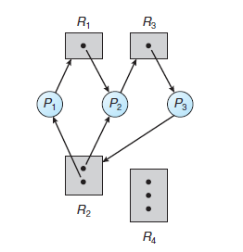
Resource allocation graph with a deadlock
- Consider a process P3 requests an instance of resource type R2. Since no resource instance is currently available, we add a request edge P3→ R2 to the graph.
- Two minimal cycles exist in the system:
P1 → R1 → P2 → R3 → P3 → R2 → P1
P2 → R3 → P3 → R2 → P2
- Processes P1, P2, and P3 are deadlocked.
- Process P2 is waiting for the resource R3, which is held by process P3. Process P3 is waiting for either process P1 or process P2 to release resource R2. In addition, process P1 is waiting for process P2 to release resource R1.
- If each resource type has several instances, then a cycle does not necessarily imply that a deadlock has occurred.
- In the following diagram there is a cycle P1 → R1 → P3 → R2 → P1.But there is no deadlock.
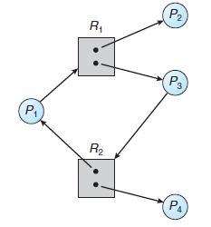
Resource allocation graph with a cycle but no deadlock.
- P4 may release its instance of resource type R2. That resource can then be allocated to P3, breaking the cycle.
- If a resource-allocation graph does not have a cycle, then the system is not in a deadlocked state. If there is a cycle, then the system may or may not be in a deadlocked state.

METHODS FOR HANDLING DEADLOCKS:

- The method for handling deadlocks include
- Deadlock avoidance or Deadlock Prevention.
- Deadlock Detection
- Deadlock Recovery.
DEADLOCK PREVENTION:
- Deadlock preventionprovides a set of methods to ensure that at least one of the four necessary conditions cannot hold. These methods prevent deadlocks by constraining how requests for resources can be made.
MUTUAL EXCLUSION:
- The mutual exclusion condition must hold. That is, at least one resource must be non-sharable
- Sharable resources, in contrast, do not require mutually exclusive access and thus cannot be involved in a deadlock.
- Read-only files are a good example of a sharable resource. If several processes attempt to open a read-only file at the same time, they can be granted simultaneous access to the file.
- We cannot prevent deadlocks by denying the mutual-exclusion condition for the non-sharable resources
HOLD AND WAIT:
- Whenever a process requests a resource, it does not hold any other resources.
- This allows a process to request resources only when it has none. A process may request some resources and use them.
- Before it can request any additional resources, it must release all the resources that it is currently allocated.
NO PREEMPTION:
- If a process is holding some resources and requests another resource that cannot be immediately
allocated to it, then all resources the process is currently holding are preempted.
- The preempted resources are added to the list of resources for which the process is waiting.
- The process will be restarted only when it can regain its old resources, as well as the new ones that it is requesting.
CIRCULAR WAIT:
- One way to ensure that this condition never holds is to impose a total ordering of all resource types and to require that each process requests resources in an increasing order of enumeration.
- Let R = {R1, R2, ...,Rm} be the set of resource types.
- Assign to each resource type a unique integer number, which allows us to compare two resources and to determine whether one precedes another in our ordering.
- If the set of resource types R includes tape drives, disk drives, and printers, then the function F might be defined as follows:
F(tape drive) = 1
F(disk drive) = 5
F(printer) = 12
- Each process can request resources only in an increasing order of enumeration.
- That is, a process can initially request any number of instances of a resource type —say, Ri.
- After that, the process can request instances of resource type Rjif and only if F(Rj) > F(Ri).
- Example, a process that wants to use the tape drive and printer at the same time must first request the tape drive and then request the printer.

DEADLOCK AVOIDANCE:
- .Deadlock avoidancerequires that the operating system be given additional information in advance concerning which resources a process will request and use during its lifetime.
SAFE STATE:
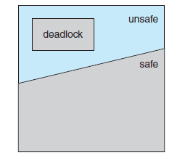
- A state is safe if the system can allocate resources to each process in some order and still avoid a deadlock.
- A system is in a safe state only if there exists a safe sequence.
- A safe state is not a deadlocked state. Conversely, a deadlocked state is an unsafe state.
- Not all unsafe states are deadlocks; however an unsafe state may lead to a deadlock.
- A sequence of processes <P1, P2, ..., Pn>is a safe sequence for the current allocation state if,
the resource requests that Pi make can be satisfied by the currently available resources plus the resources held by all Pj, with j < i.
- Example: consider a system with twelve magnetic tape drives and three processes: P0, P1, and P2
- Process P0 requires ten tape drives, process P1 may need as many as four tape drives, and process P2 may need up to nine tape drives.
- Suppose that, at time t0, process P0 is holding five tape drives, process P1 is holding two tape drives, and process P2 is holding two tape drives
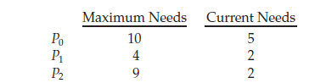
- At time t0, the system is in a safe state. The sequence <P1, P0, P2>satisfies the safety condition.
- Process P1 can immediately be allocated all its tape drives and then return them (the system will then have five available tape drives);
- Then process P0 can get all its tape drives and return them (the system will then have ten available tape drives); and finally process P2 can get all its tape drives and return them (the system will then have all twelve tape drives available).
RESOURCE ALLOCATION GRAPH:
- A new type of edge, called a claim edge is used in resource allocation graph.
- A claim edge Pi → Rjindicates that process Pi may request resource Rjat some time in the future.
- When process Pi requests resource Rj, the claim edge Pi → Rjis converted to a request edge.
- When a resource Rjis released by Pi, the assignment edge Rj→ Pi is reconverted to claim edge Pi ->Rj
.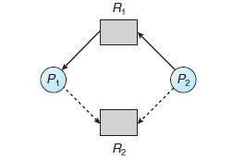
- Now suppose that process Pi requests resource Rj. The request can be granted only if converting the request edge Pi → Rjto an assignment edge Rj→ Pi does not result in the formation of a cycle in the resource-allocation graph.
- If no cycle exists, then the allocation of the resource will leave the system in a safe state. If a cycle is found, then the allocation will put the system in an unsafe state.
BANKERS ALGORITHM:
- When a new process enters the system, it must declare the maximum number of instances of each resource type that it may need.
- This number may not exceed the total number of resources in the system.
- When a user requests a set of resources, the system must determine whether the allocation of these
resources will leave the system in a safe state.
- If it will, the resources are allocated; otherwise, the process must wait until some other process releases enough resources.
- The following data structures are needed to implement bankers algorithm, where n is the number of
processes in the system and m is the number of resource types:
• Available: Length m indicates the number of available resources of each type.
• Max. An n × m matrix defines the maximum demand of each process.
• Allocation. An n × m matrix defines the number of resources of each type currently allocated.
• Need. An n × m matrix indicates the remaining resource need of each process.
1. SAFETY ALGORITHM:
It is an algorithm for finding out whether or not a system is in a safe state
- LetWorkand Finish be vectors of length m and n, respectively. Initialize Work = Available and Finish[i] = false for i = 0, 1, ...,n − 1.
- Find an index i such that both
a. Finish[i] == false
b. Needi≤Work
If no such i exists, go to step 4
- Work =Work + Allocationi
Finish[i] = true
Go to step 2.
- If Finish[i] == true for all i, then the system is in a safe state.
This algorithm may require an order of m × n² operations to determine whether a state is safe.
2. RESOURCE REQUEST ALGORITHM:
- This is an algorithm for determining whether requests can be safely granted.
- Let Requestibe the request vector for process Pi.
1. If Requesti≤Needi, go to step 2. Otherwise, raise an error condition, since the process has exceeded its maximum claim.
2. If Requesti≤ Available, go to step 3. Otherwise, Pi must wait, since the resources are not available.
3. Have the system pretend to have allocated the requested resources to process Pi by modifying the state as follows:
Available = Available–Requesti;
Allocationi= Allocationi+ Requesti;
Needi= Needi–Requesti;
- If the resulting resource-allocation state is safe, the transaction is completed, and process Pi is allocated its resources.
- However, if the new state is unsafe, then Pi must wait for Requesti,and the old resource-allocation state is restored.

DEADLOCK DETECTION:
A Deadlock detection algorithm examines the state of the system to determine whether a deadlock has occurred
SINGLE INSTANCE OF EACH RESOURCE TYPE:
- If all resources have only a single instance, then we can define a deadlock detection algorithm that uses a variant of the resource-allocation graph, called a wait-for graph.
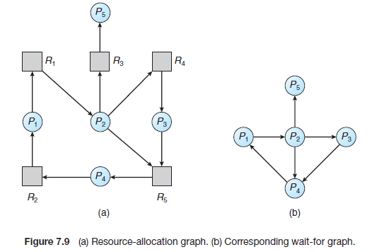
- This graph is obtained from the resource-allocation graph by removing the resource nodes and collapsing the appropriate edges.
- A deadlock exists in the system if and only if the wait-for graph contains a cycle.
- To detect deadlocks, the system needs to maintain the wait for graph and periodically invoke an algorithm that searches for a cycle in the graph.
SEVERAL INSTANCE OF RESOURCE TYPE:
- The wait-for graph scheme is not applicable to a resource-allocation system with multiple instances of each resource type
- This algorithm uses the following data structure,
• Available. A vector of length m indicates the number of available resources of each type.
• Allocation. An n × m matrix defines the number of resources currently allocated to each process.
• Request. An n × m matrix indicates the current request of each process.
1. LetWorkand Finish be vectors of length m and n, respectively. Initialize Work = Available. For i = 0, 1, ...,n–1, if Allocationi_= 0, then Finish[i] = false. Otherwise, Finish[i] = true.
2. Find an index i such that both
a. Finish[i] == false
b. Requesti≤Work
If no such i exists, go to step 4.
3. Work =Work + Allocationi
Finish[i] = true
Go to step 2.
4. If Finish[i] ==false for some i, 0≤i<n, then the system is in a deadlocked state.
Moreover, if Finish[i] == false, then process Pi is deadlocked.
This algorithm requires an order of m × n2 operations to detect whether the system is in a deadlocked state.
DEADLOCK RECOVERY:
- When a detection algorithm determines that a deadlock exists ,the possibility is to let the system recover from the deadlock automatically
- There are two options for breaking a deadlock.
1. PROCESS TERMINATION:
- It is the process of eliminating the deadlock by aborting a process. It involves two methods
- Abort all deadlocked process: This method breaks the deadlock cycle but with a greater expense.
- Abort one process at a time until the deadlock cycle is eliminated: This method aborts the deadlocked process one by one and after each process is aborted, it checks whether any process are still deadlocked.
2. RESOURCE PREEMPTION:
- To eliminate deadlocks Preempt some resources from the process and give the resource to other process until the deadlock cycle is broken.
- Selecting an victim: It is the process of selecting which resource and which process are to be preempted.
- Rollback: If we preempt a resource from a process, it cannot continue with its normal execution; it is missing some needed resource. We must roll back the process to some safe state and restart it from that state.
Starvation: The resources will not always be preempted from the same process, else it leads to starvati

